Logan Hoots, Lucio Infante, Karan Sharma

CST - 461 - WF700A

Professor Isac Artzi

Ethereum Development

1. Objectives and Features of the App

The objective of the program was to create a smart contract that had functions that would allow an autonomous vehicle to give rides to people. The app has an authentication feature that will get the user’s password and that will allow for the ride to be summoned, which is another feature. The car summoning feature has most of the features for the app, this includes having the user trying to use the app, authentication, the car that will be picking the person, and how far the ride will be. Since the service is autonomous the app needed a feature that allowed it to see how often it needed to get serviced, allowing for the service to run smoothly for the users. As a service and a business there needs to be some type of cost for the rides in order to be profitable and maintain the service at the quality needed. The cost is related to how far the ride will be plus the starting price which is 20. The app will be able to give informatics on the total cost, miles, and time, plus the user and cars that are in the app currently.

1. Skeleton Code

All code has been submitted with the document.

1. Smart Contract

All code has been submitted with the document.

1. Compile and Deploy

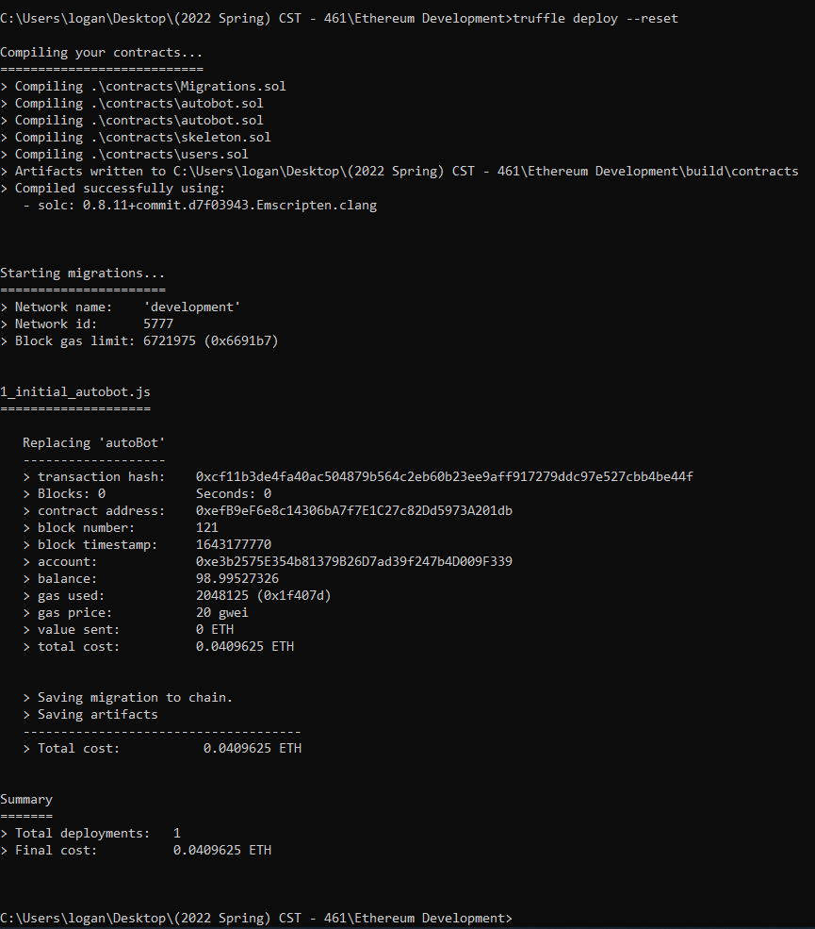

1. Invoke functions

Instance

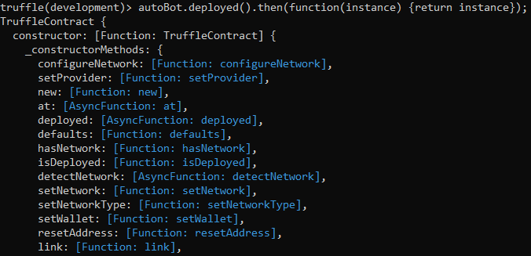

addCar

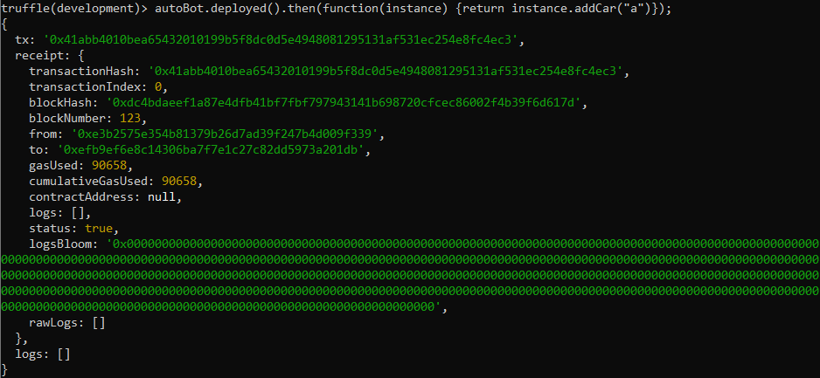

addUser

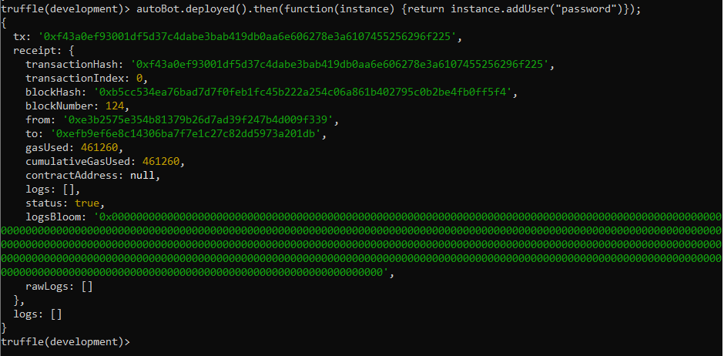

summonRide

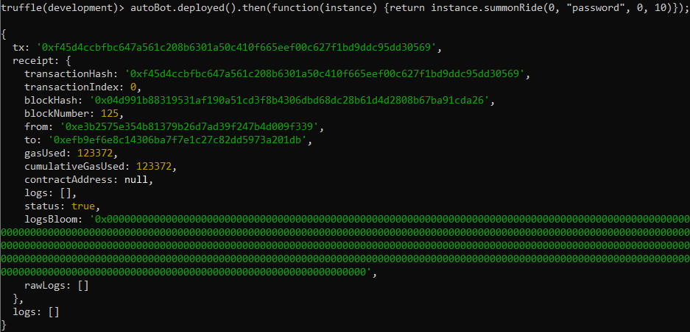

displayVehicleStatus



displayNextService

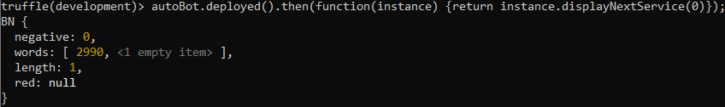

displayTotals

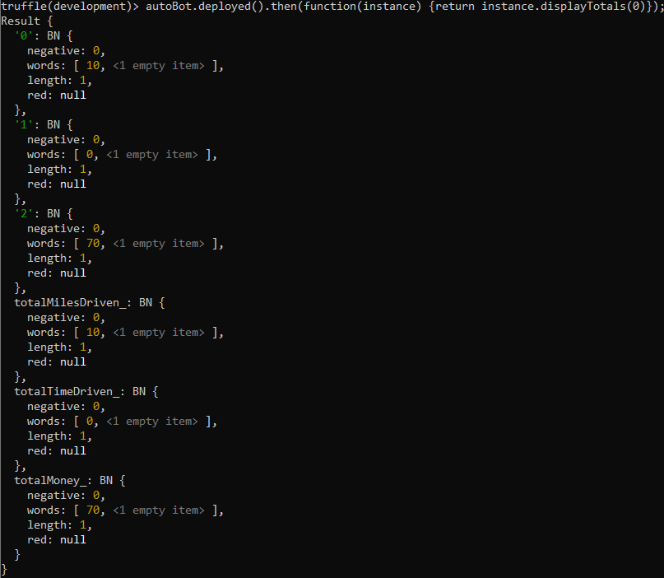

displayUserProfiles



displayCarProfiles

